G-418 Sulfate , Geneticin
# MG9028
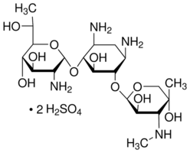
CAS No. ： 108321-42-2 Formula：C₂₀H₄₀N₄O₁₀ ·2H₂SO₄
Molecular weight：692.71 Appearance： white powder
Specific Rotation： +104º ― +121º Moisture： ≤10%

Potency： > 700 ug/mg

Introduction
G-418 sulfate has originally been derived from Micromonospora rhodoranga NRRL 5326. G-418 sulfate is an aminoglycosidic antibiotic, it acts by interfering with protein synthesis and is usually used as an agent for selection of cultured cells expressing a gene that confers resistance to G-418. It is toxic to both prokaryotic and eukaryotic cells. This compound has been shown to cause a bypass of nonsense mutations during translation. Experiments have shown that Geneticin Sulfate inhibits the incorporation of amino acids into protein and can destroy fibroblasts. Mechanistic studies suggest that this agent affects the 80S ribosomes and inhibits the elongation cycle. Further studies report that Geneticin Sulfate is highly active against amoebae, protozoa, tapeworm, and pinworm exposed murine cells. G-418 is white powder, is shipped at room temperature, dry powder should be stored at RT and solution at -20℃.

Cat.No. | Product Name | Package
MG9028-500MG | G-418 Sulfate，Geneticin | 500MG
MG9028-1G | G-418 Sulfate，Geneticin | 1G
MG9028-5G | G-418 Sulfate，Geneticin | 5G

For Research Use Only. Not Intended for Diagnostic or Therapeutic Use.

